**Student Name: Wenqing Zhao**

**Student Number: 21211886**

**Question Set 1**

1. What is the total number of ICMP simulation events?

There are 6 ICMP messages in one request and there are 4 request during one ping command. So the total number of ICMP simulation events is 24.

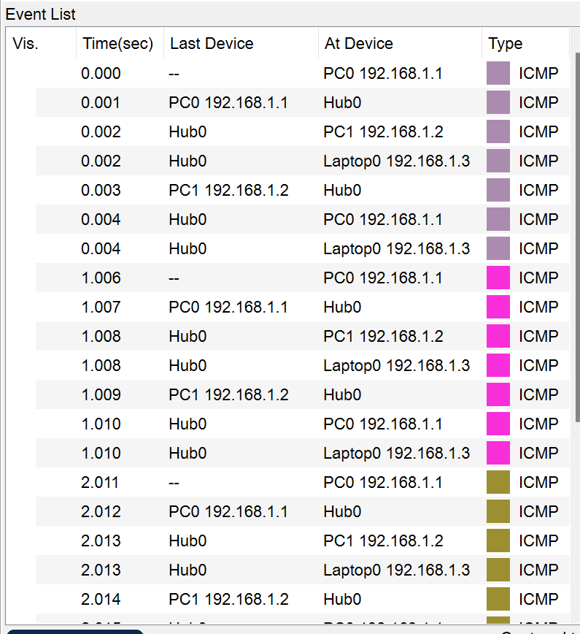

1. What does the hub do with ICMP messages that it receives?

When the hub receives ICMP messages, it will broadcast the messages to all devices connected to the it.

1. Does the hub have a MAC address?

No, the hub doesn’t has a MAC address.

1. Does the hub use the MAC addresses on the messages that it receives?

No, it doesn’t use the MAC addresses. Because when it receives the messages, it will broadcast to all devices which connected to it. So it does not need to use MAC addresses.

**Question Set 2**

1. Can the sniffer see what websites/servers the laptop is visiting?

Yes, it can see the ip address of servers.

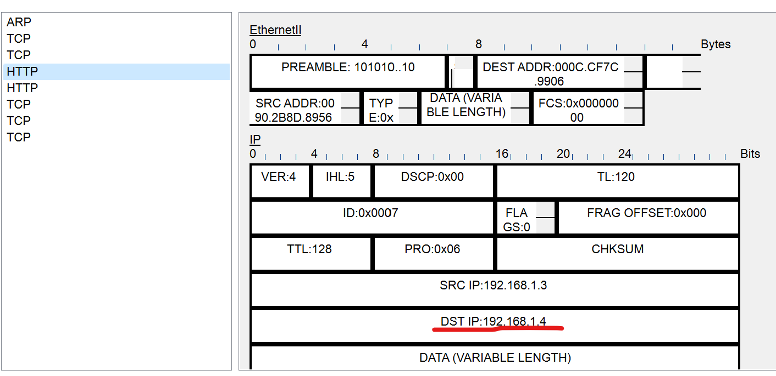

1. What about the content of the websites?

Yes, it can see the content of the websites.

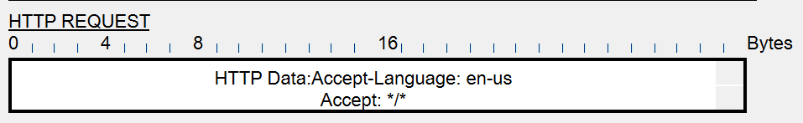

**Question Set 3**

1. How many ICMP simulation events are there this time?

There are 4 ICMP messages in one request and there are 4 request during one ping command. So the total number of ICMP simulation events is 16.

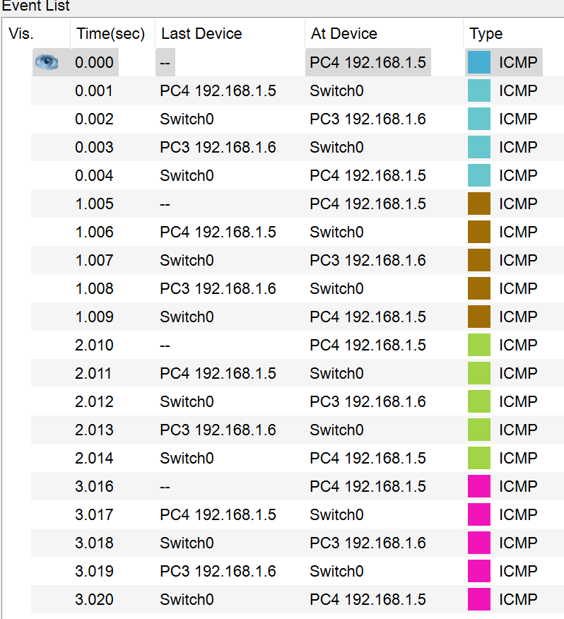

1. Contrast the behaviour in this topology with what you saw when a hub was used instead of a switch?_

When the message is delivered to hub, hub broadcasts it. But when the message is delivered to switch, switch sends it to the corresponding device based on its stored mac address and ip address.

**Question Set 4**

1. Does the sniffer know what web page was requested by PC3? Why

Because the switch has a mac address table that stores the Mac address of each device connected to it. When PC3 requests a web page, the switch sends the request directly to the server and not to the sniffer.

1. Perform pings from each device to every other device. Write down the contents of Switch0 and Switch1 Mac Address Tables.

